**7.3.2.5 Packet Tracer – Verifying IPv4 and IPv6 Addressing**

Student Name: Lee Kai Yang

Student ID: 19WMR11671

Tutorial Group: RSF1S3G1

**Topology**

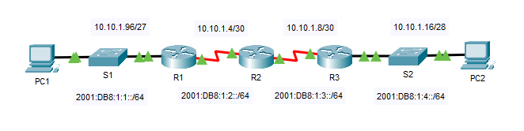

**Results Activity**



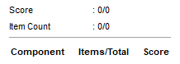

**Questions**

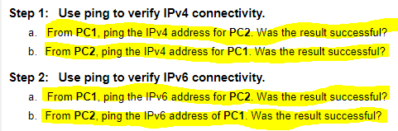

1. From **PC1**, ping the IPv4 address for **PC2**. Was the result successful?

Yes

1. From **PC2**, ping the IPv4 address for **PC1**. Was the result successful?

Yes

1. From **PC1**, ping the IPv6 address for **PC2**. Was the result successful?

Yes

1. From **PC2**, ping the IPv6 address for **PC1**. Was the result successful?

Yes

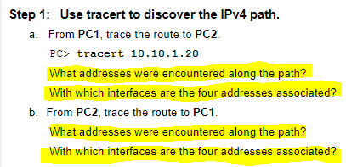

From **PC1**, trace the route to **PC2**.

1. What addresses were encountered along the path?

10.10.1.97, 10.10.1.5, 10.10.1.10, 10.10.1.20

1. With which interfaces are the four addresses associated?

G0/0 of R1, S0/0/0 on R2, S0/0/01 on R3, NIC of PC2

From **PC2**, trace the route to **PC1**.

1. What addresses were encountered along the path?

10.10.1.17, 10.10.1.9, 10.10.1.6, 10.10.1.100

1. With which interfaces are the four addresses associated?

G0/0 of R3, S0/0/1 of R2, S0/0/1 of R1, NIC of PC1

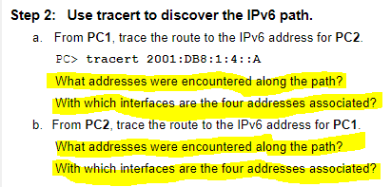

From **PC1**, trace the route to the IPv6 addresses for **PC2**.

1. What addresses were encountered along the path?

2001:DB8:1:1::1, 2001:DB8:1:2::1, 2001:DB8:1:3::2, 2001:DB8:1:4::A

1. With which interfaces are the four addresses associated?

G0/0 of R1, S0/0/0 of R2, S0/0/1 of R3, NIC of PC2

From **PC2**, trace the route to the IPv6 addresses for **PC1**.

1. What addresses were encountered along the path?

2001:DB8:1:4::1, 2001:DB8:1:3::1, 2001:DB8:1:2::2, 2001:DB8:1:1::A

1. With which interfaces are the four addresses associated?

G0/0 of R3, S0/0/1 of R2, S0/0/1 of R1, NIC of PC1